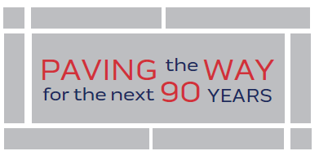
When you have visited the Tennessee Trucking Association headquarters, I hope you have noticed the 43 company or individuals’ names on pavers at the entrance to our building. The people and companies inscribed on these pavers contributed to the retirement of our building’s mortgage when we initiated this practice in 1996. As we celebrate our 90th year as an Association, I am inviting you to join me in PAVING THE WAY FOR THE NEXT 90 YEARS!
The cost of each paver is $500.00, and, since all payments will be made to the Tennessee Trucking Foundation, all purchases are 100% tax deductible. Flexible payment terms; You can do 1 payment of $500.00, 2 payments of $250.00 or 4 payments of $125.00.
There are 250 blank pavers at our entrance, 45 of which are already committed to by the Foundation Board and Executive Committee. These pavers could be dedicated to any one or more of the following; a TTA member carrier or allied company, a loved one, either present or past, an employee, either past or present, a Road Team Captain, either past or present, a TTA Award winner, a Safety Professional of the Year, a Maintenance Professional of the Year, an Allied Professional of the Year, a Young Professional of the Year, a Technician Skills Grand Champion, a Truck Driving Championship Grand Champion, a Tennessee Driver of the Year, a Fleet Safety Award Grand Champion, just to name some of the possibilities.
Our first bricks have been purchased by Dave Huneryager. Below is a sample what his bricks will look like.
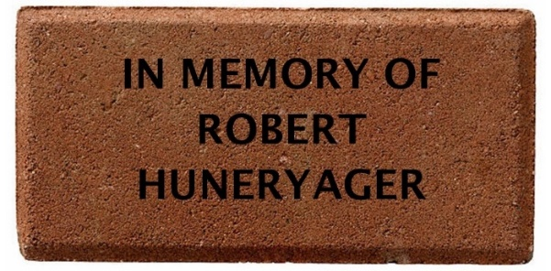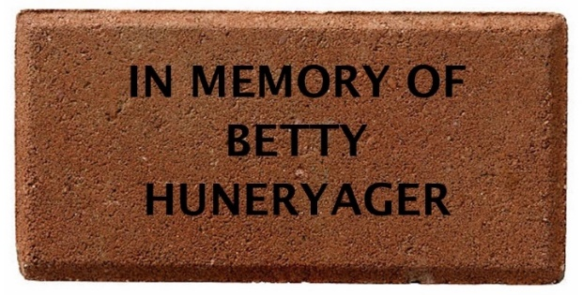
You can do 3 lines at 14 characters each. Please fill in the below on what you would like on your brick. Please do 1 page for each brick purchased.
Line 1 Click or tap here to enter text.
Line 2 Click or tap here to enter text.
Line 3 Click or tap here to enter text.
☐Please invoice me ☐Check ☐Pay by credit card
Name on Card: Click or tap here to enter text.
Billing Address:Click or tap here to enter text.
City: Click or tap here to enter text.State: Click or tap here to enter text. Zip: Click or tap here to enter text.
Credit Card Number: Exp: Security Code:
To help cover the cost of processing payments, we add a 3.5% fee for credit cards. This fee is not more than the cost of accepting these cards. There is no fee for debit cards.

